Sample Email For John Romaniello’s Superhero Workout

Headline: How To Look Like BATMAN!

What if you could look like any superhero you wanted?

Ok fine I'll admit it..... I always wanted to look like BATMAN.

I remember as a kid, laying on my bed, blazing through comic after comic.
Here was a guy who, despite having ZERO powers, was able to go toe-to-toe with the best of them.

Batman had trained under every style of martial arts, was a world-class detective, and had muscles the size of my head!

Basically he was the peak of human perfection!
To be like him, would be a dream come true.

But in reality, I was the complete opposite.
I was a short, pudgy, 30 pounds, overweight teenager.

Throughout all of high-school not a single girl paid me any mind.
I would look at the football jocks in envy, as girls would fawn over them.
They'd wrap their hands around their broad biceps and happily follow them to class.
Why couldn't that be me??

I wanted the kind of action-hero physique you could only see on TV?
Was this too big of a fantasy?

For a while, I truly believed it was.

But then years later, after experimenting and testing every kind of workout and fitness theory, I discovered John Romaniello's SECRET to getting a Superhero body.

Now I'm on the cover of men's magazines. My Instagram is flooded with messages from gorgeous smoke-show girls, desperate to meet up with me.
When people see how I look, they think it's due to genetics.
But no!

It was due to proper strategy.

And now I wanna share that strategy with you.

==> The Superhero Workout Program (Look Like A Movie Star!)

Over 11,999 BADASSES have tried it and they can't believe the results.

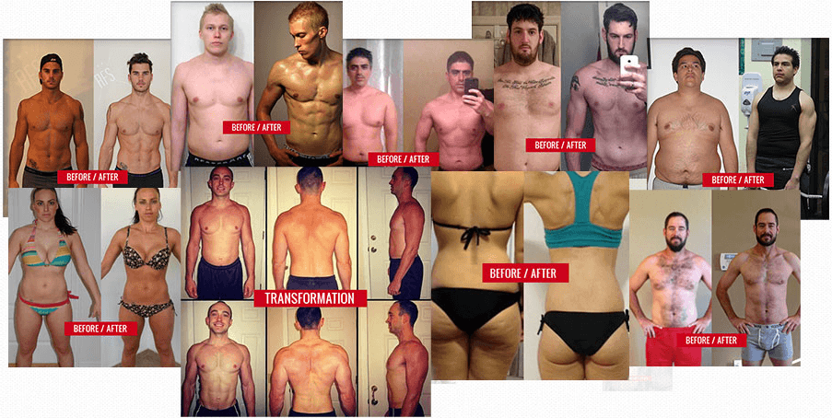

See all your life you've been lied to.

People said that abs are based on genetics. They said you’re naturally an endomorph, you can't change it.

BULLSHIT!!!

I'm living proof that you can.
I know what it was like to never feel attractive. To look in the mirror and turn away in disappointment.

That's why I'm on a mission to help as many guys as possible get that superhero body.

So here's what I'm gonna do.... I'm gonna give you my SECRET workout plan for 50% OFF.

But since it's such a huge gift, I can only offer it up until tomorrow midnight.

==> The Superhero Workout Program (50% OFF - Limited Time)

Don't miss out!

Can't wait to add your transformational picture to the rest of these fine-looking badasses.

Alright stud, I gotta go hit the gym. Today's leg day. And my legs are getting brolic!
Do you think I'll tear through these jeans?

Lol I hope so!

Alright later dominator.
- Andrew Jamel, Team Roman

